* Let’s try to measure the intangibles that specific athletes have
  + Focus on Clutch! High performance/sustained performance during high pressure situations

Primary study is to understand what metrics make a player ‘clutch’?

* Whet are high pressure situations?
  + Shot clock, 4th quarter, playoffs
* Which metrics appear to have great variability during clutch/high pressure situations?
  + Passing, shooting, defending – decision making
* Different types of players will have different pressures depending on role
* Are similar types of players experiencing the same variability?
  + Brings up a side project of finding similar players by looking at specific statistics.
    - One option is splitting the players up by their positions, but I also want to look into potentially creating new classifications based on stats
    - Euclidean distance example with Kyle Lowry
* In the end, with separate groups of players, I’d like to create a metric that will incorporate the the role of the player, and their performance under high pressure situations. Measure the change in specific key stats, tailored towards a player’s role

Personally interesting to me since Toronto has a free agent Kyle Lowry -> clutch and we need to shop around for replacements. See how similar the other players are on the market, and if they have the same clutch gene that Kyle has!

Data coming from NBA.com – Scraped from a useful API called nba_py. This helps sift through the gigabyts of nba data, and allows me to access the data in a key-pair database structure.

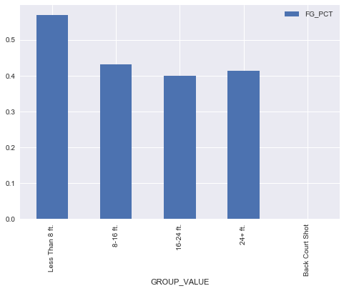

Kyle Lowry Regular shooting splits

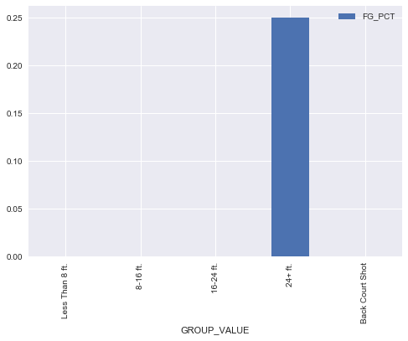

Kyle Lowry Shooting splits when shot clock is off

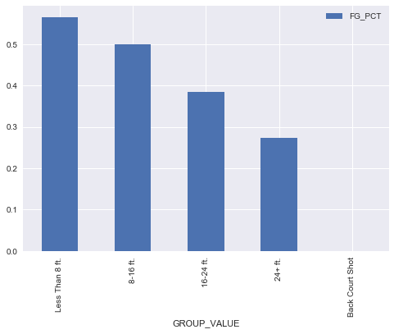

DeMar DeRozan regular shooting splits

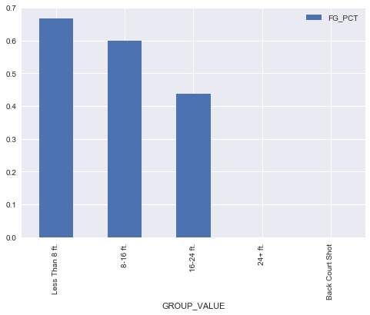

DeMar DeRozan’s shooting splits when shot clock is turned off

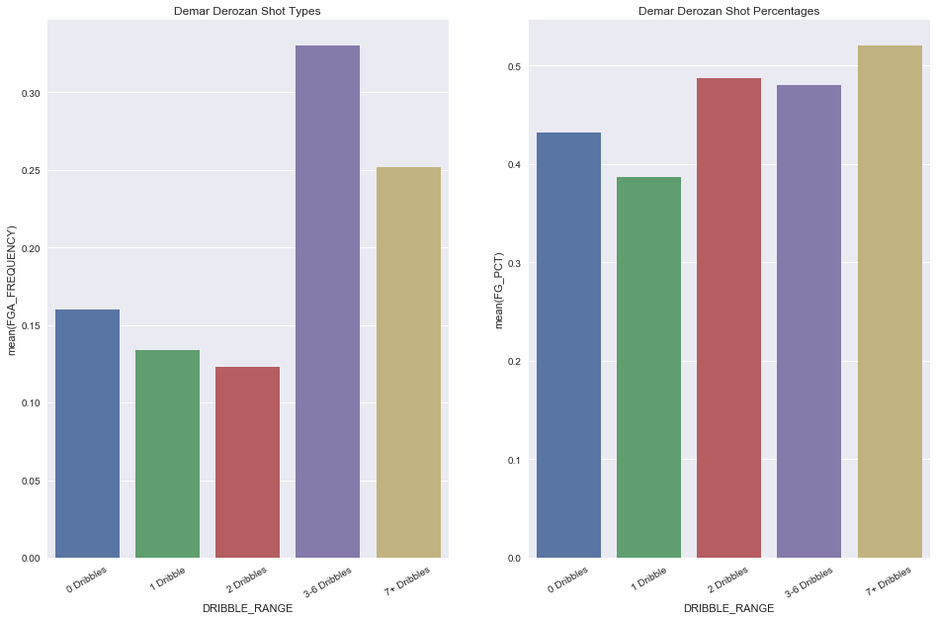

DeRozan dribble profile

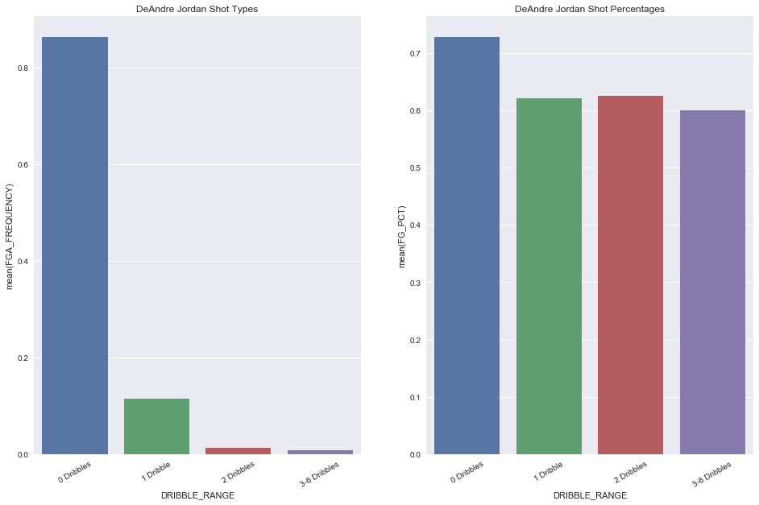

DeAndre Jordan Dribble profile